PRESS RELEASE | PARIS, 2 february 2026

SKEMA and UTC join forces to shape the future of project management
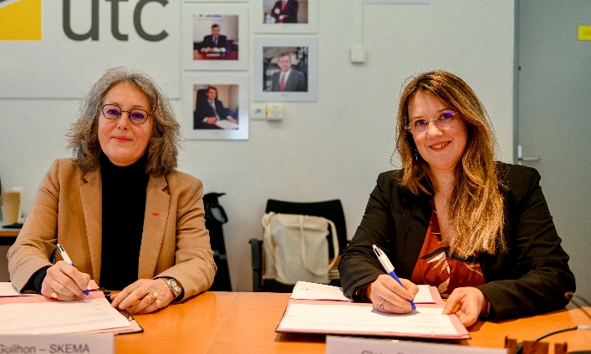 | 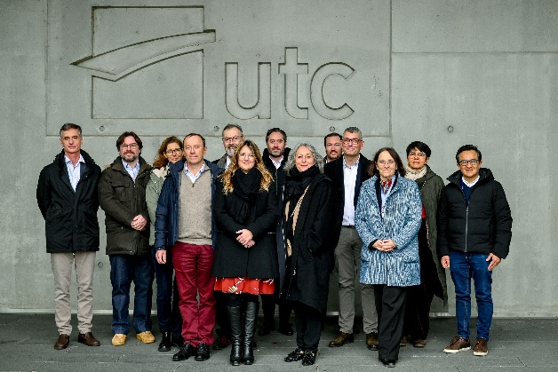
On the left: Alice Guilhon, Dean & Executive President of SKEMA Business School, and Claire Rossi, President of the University of Technology of Compiègne (UTC). On the right: the founding teams of the Chair.
Growing complexity, economic uncertainty, and artificial intelligence are ushering project management into a new era. To achieve sustainable performance, organisations must adopt new, multidimensional approaches. It is against this backdrop that SKEMA Business School, the University of Technology of Compiègne (UTC), and the UTC Foundation for Innovation are launching the Chair “The Future of Project Management”, in partnership with Renault Group and Saint-Gobain.

An official launch in Compiègne
Officially launched on 29 January 2026 on the campus of the University of Technology of Compiègne, in the presence of Claire Rossi, President of UTC, and Alice Guilhon, Dean & Executive President of SKEMA Business School, the Chair “The Future of Project Management” aims to bridge academic research with the very concrete challenges faced by major industrial organisations.
The Chair is jointly led by two co-holders: Thierry Gidel, Associate Professor in Management Science and Industrial Engineering, Head of the Innovative Project Management track at UTC, and Paul Gardiner, Professor at SKEMA Business School and Director of the MSc Project Management for Business Development.

Three pillars to rethink project management
The Chair’s research programme is structured around three complementary pillars, firmly rooted in today’s industrial challenges.
The first pillar, “Resilience & Robustness”, focuses on governance and decision-making in uncertain environments. Research includes real-time optimisation of project portfolios, AI-enhanced risk analysis, and the development of governance frameworks that can absorb shocks and adapt rapidly.
The second pillar, “People & Collaboration”, places human factors back at the heart of project performance. It explores cognitive load, stress, collaboration within hybrid teams, and the impact of digitalisation on trust, cooperation, and engagement.
Finally, the “Innovation & Efficiency” pillar examines the transformation of project management practices, tools and roles, particularly in environments integrating artificial intelligence, collaborative platforms, and new ways of working.

A leading academic team
The Chair is supported by a multidisciplinary academic team.
On the UTC side, Thierry Gidel works alongside Christine Divry-Groff, Associate Professor in Economics and Management Sciences, and Oscar Avila, Associate Professor in Project Management and member of the teaching team for the Innovative Project Management track.
On the SKEMA Business School side, the research involves Paul Gardiner, Christian Linder (Professor of Strategy and Director of the Global DBA), Eliane Bacha (Professor of Organisational Behaviour), Assistant Professors Daniela Iubatti and Sarra Dahmani, as well as Desmond McGetrick (Director of the MS® Manager des Projets et Programmes​).

Renault Group and Saint-Gobain, founding industrial partners
In addition to the direct involvement of the UTC Foundation for Innovation, which acts as a catalyst for the Chair’s programme and is chaired by Patrick Dupin, Group Chief Operating Officer of Saint-Gobain, two major industrial groups – Renault Group and Saint-Gobain – are the first founding corporate partners.
Renault Group is represented by Frédéric d’Arrentières, Expert Leader in Project Management within the Group and President of SMaP (France IPMA). Saint-Gobain is represented by Vincent Toni, Group PMO, responsible for strengthening the Group’s project management maturity and integrating digital transformation and artificial intelligence challenges.
With an initial duration of four years and a starting budget of €100,000 per year, the Chair aims to welcome new industrial partners in the near future and to produce high-level academic research to develop new methods, content, and tools that are directly operational for companies.
“The future of project management lies at the intersection of engineering, human factors, and innovation: this is precisely what this Chair seeks to shed light on,” explain Thierry Gidel and Paul Gardiner.
“The relationship of trust that binds us to the University of Technology of Compiègne is invaluable, and we are very proud to go even further by supporting, through our investment, the Chair ‘The Future of Project Management’. At Saint-Gobain, we are committed to enabling our talents and those of our ecosystem to remain at the forefront of innovation and to continuously deliver innovative solutions in response to the challenges faced by major organisations. We are convinced that this notably requires a close relationship between major technology players and the academic world,” explains Patrick Dupin, President of the UTC Foundation for Innovation and Group Chief Operating Officer of Saint-Gobain.

About SKEMA Business School

With 11,000 students from over 130 nationalities, 190 professors, and 63,000 alumni in 145 countries, SKEMA Business School is a global education and research institution that develops committed talent to transform the world sustainably. The hybridisation of social sciences and data sciences is at the heart of its model, and global exposure is its operational mode.

Multi-accredited (AACSB, EQUIS, EFMD Accredited EMBA), the school is recognised worldwide for its research, its more than 70 excellent programmes, and its international multi-campus structure across six countries: South Africa, Brazil, Canada, China, the United Arab Emirates, the United States, and France.

www.skema-bs.fr

About the University of Technology of Compiègne (UTC)
University of Technology of Compiègne (UTC), a public higher education institution dedicated to science, culture and professional training, and a member of the Sorbonne University Alliance, was founded in 1972 as an experimental university of technology. Through its statutes and academic model, it combines the strengths of a university with those of an engineering school, asserting a unique position within the French and European higher education landscape.

A true regional innovation ecosystem, regularly ranked among the very top public post-baccalaureate engineering schools, UTC works closely with society and the socio-economic world. It anticipates companies’ research and skills needs while facilitating the professional integration of its 4,400 students.

Built on a pedagogy of autonomy and on interdisciplinary technological research focused on innovation, UTC educates engineers, master’s graduates and doctoral researchers capable of understanding the interactions between technology, humanity and society, and of evolving in a highly competitive international environment, with a constant commitment to responsibility and sustainable development.

This excellence is recognised by the socio-economic community: 95% of companies believe that UTC effectively prepares future engineers for the challenges ahead, and 82% consider that it fosters creativity and innovation.
UTC’s faculty members, researchers and engineers therefore give meaning to innovation by encouraging the emergence of new scientific and technological fields, and by placing entrepreneurship, educational innovation and learning at the heart of their priorities, within a dynamic strengthened by membership of the Sorbonne University Alliance.

www.utc.fr
About the UTC Foundation for Innovation
The UTC Foundation for Innovation accelerates projects that make a meaningful contribution to building the world of tomorrow. Its vision is clear and forward-looking: to create a more humane and sustainable future, society needs innovation – a world in which people and technology work in harmony.

Working alongside UTC, its corporate partners and alumni, the UTC Foundation for Innovation supports and accelerates research, entrepreneurial, educational and socially responsible projects with a strong sustainability focus.

One of the Foundation’s main objectives is to build a “transformative institutional alliance” to address new societal challenges and anticipate changes in UTC’s environment. This alliance enables companies and their expertise to become genuine stakeholders and to rise to the challenges of technology, international development, innovation, entrepreneurship and equal opportunities.

A Foundation dedicated to accelerating innovative projects and shaping the sustainable world of tomorrow.

PRESS CONTACTS:

SKEMA Business School University of Technology of Compiègne
Christine Cassabois Odile Wachter
Tél. +33 (0)6 27 49 36 59 Tél. +33 (0) 6 45 49 53 34
christine.cassabois@skema.edu odile.wachter@utc.fr
pauline.seban@utc.fr

